Functional Requirements

* The Food Truck Management System shall provide the ability to check a staff member’s schedule by selecting a staff member.

**(ID: 1000) (PRIORITY: MEDIUM)**

* The Food Truck Management System shall provide the ability to display a list of the truck’s staff members along with their corresponding roles.

**(ID: 1001) (PRIORITY: MEDIUM)**

* The Food Truck Management System shall provide the ability to add a staff member by specifying the staff member’s name along with their role.

**(ID: 1002) (PRIORITY: HIGH)**

* The Food Truck Management System shall provide the ability to assign a schedule to an existing staff member by specifying the date, start time and end time of the shift.

**(ID: 1003) (PRIORITY: HIGH)**

* The Food Truck Management System shall provide the ability to display a list of the truck’s equipment along with their corresponding quantities.

**(ID: 1010) (PRIORITY: MEDIUM)**

* The Food Truck Management System shall provide the ability to add to the equipment supply by specifying the equipment’s name and additional quantity.

**(ID: 1011) (PRIORITY: HIGH)**

* The Food Truck Management System shall provide the ability to remove from the equipment supply by specifying the equipment’s name and used up quantity.

**(ID: 1012) (PRIORITY: HIGH)**

* The Food Truck Management System shall provide the ability to display a list of the truck’s food supplies along with their corresponding quantities.

**(ID: 1020) (PRIORITY: MEDIUM)**

* The Food Truck Management System shall provide the ability to add to the food supply by specifying the supply’s name and additional quantity.

**(ID: 1021) (PRIORITY: HIGH)**

* The Food Truck Management System shall provide the ability to remove from the food supply by specifying the supply’s name and used up quantity.

**(ID: 1022) (PRIORITY: HIGH)**

* The Food Truck Management System shall provide the ability to keep track of the number of sales of a certain menu item by allowing the user to claim that a specific item was sold.

**(ID: 1030) (PRIORITY: MEDIUM)**

* The Food Truck Management System shall provide the ability to add a food item to the menu by specifying the item’s name.

**(ID: 1031) (PRIORITY: HIGH)**

* The Food Truck Management System shall provide the ability to display a popularity report that consists of the truck’s menu items sorted by their number of sales.

**(ID: 1032) (PRIORITY: MEDIUM)**

Non-Functional Requirements

* The Food Truck Management System shall be able to run on laptop/desktop machines.

**(ID: 2000) (PRIORITY: HIGH)**

* The laptop/desktop application of the Food Truck Management System shall be implemented in Java with the Java Swing framework.

**(ID: 2001) (PRIORITY: HIGH)**

* The Food Truck Management System shall be able to run on the Android Mobile platform.

**(ID: 2010) (PRIORITY: HIGH)**

* The mobile application of the Food Truck Management System shall be implemented in Java using the Android Studio development framework.

**(ID: 2011) (PRIORITY: HIGH)**

* The Food Truck Management System shall be able to run on web browsers.

**(ID: 2020) (PRIORITY: HIGH)**

* The server side of the web application of the Food Truck Management System shall be primarily written in PHP.

**(ID: 2021) (PRIORITY: MEDIUM)**

* The data of the Food Truck Management System shall be saved in text files.

**(ID: 2030) (PRIORITY: HIGH)**

Umple-defined Domain Model

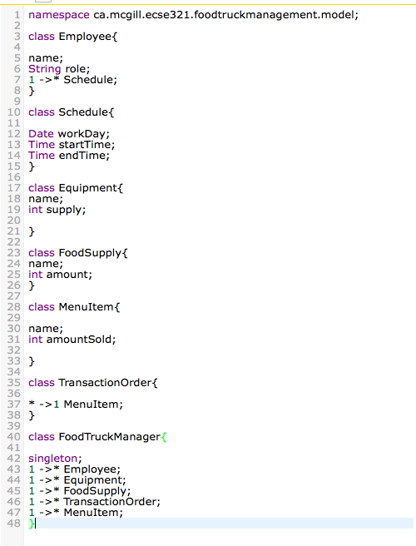

Domain Model Diagram

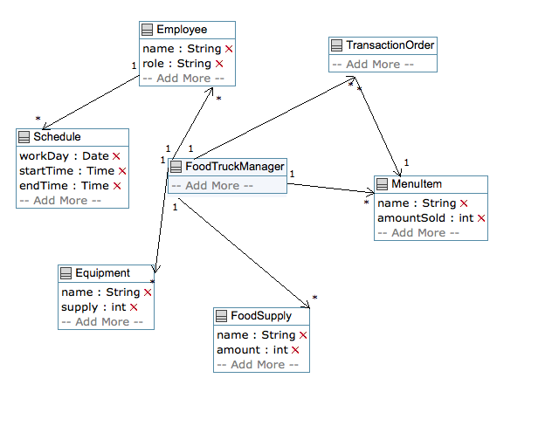

Use Case Diagram

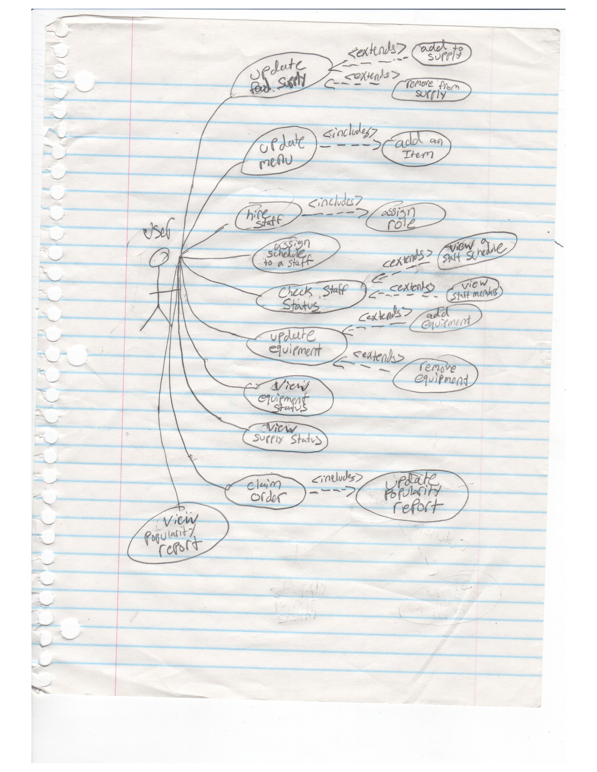

Use Case Description

* **Update Food Supply (called by manager):** Update the supply quantity and add/remove new food
* *EXTENDS* Add Supply (**ID: 1021**):
  + - Add to supply of food by updating the quantity or adding a new supply
* *EXTENDS* Remove Supply (**ID: 1022**):
  + - Remove used supply of food
* **Update Menu (called by manager):** Update the menu by adding an item
* *INCLUDES* Add Item (**ID: 1031**):
* Add an new item to the menu
* **Hire Staff (called by manager):** Hire a staff member to food truck team
* *INCLUDES* Assign role (**ID: 1002**):
* Assign a role to the staff being hired
* **Assign Schedule To A Staff Member (called by manager) (ID: 1003):** Assign a work schedule to a staff member (the hours that the staff member shall be working)by setting a date, start time and end time
* **Check Staff Status (called by manager):** Check a staff members work schedule/list all staff members
* *EXTENDS* View a staff schedule (**ID: 1000)**:
* View a staff members working hours
* *EXTENDS* View staff members (**ID: 1001**):
* View a list of all staff members
* **Update Equipment Supply (called by manager):** Update the supply/quantity of equipment
* *EXTENDS* Add Equipment (**ID: 1011**):
* Add to the quantity of the supply of equipment or add a new piece of equipment to the supply
* *EXTENDS* Remove Equipment (**ID: 1012**):
* Remove from the quantity of the supply of equipment
* **View Equipment Status (called by manager) (ID: 1010):** View a list of the equipment along with their corresponding quantities
* **View Supply Status (called by manager) (ID: 1020):** View a list of supplies along with their corresponding quantities
* **Claim Order (called by manager):** Allows the manager to claim that a specific menu item was ordered
* **\***INCLUDES**\*** Update Popularity Report (**ID: 1030**):
  + - Increment the number of sales for this specific item
* **View Popularity Report (called by manager) (ID: 1032):** View a list of menu items and their corresponding number of sales

Requirements-level Sequence Diagram (Add Food Supply)

